Mobile Workshop Descriptions

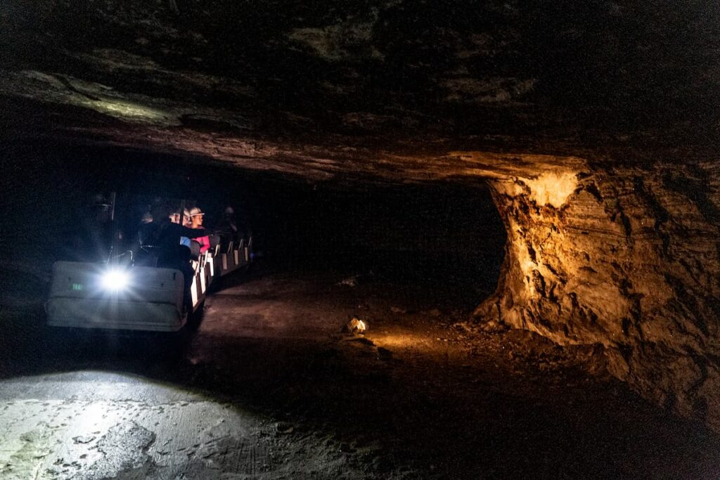
Beneath the Surface: Tourism, History & Economic Impact at Strataca Salt Mine

Date & Time: 6/17/2026, 1:00 PM Arrival (Depart Wichita @ 12:00 P.M- Return @ 4:30 PM )
Duration: 2.5 hours (Rain or Shine)
Capacity: 27 participants
Price: $55.00

Descend 650 feet underground to explore Strataca, a nationally recognized destination built within an active salt mine. This mobile workshop will examine the site’s history and the community development strategies that transform a working industrial asset into a sustainable tourism attraction. Participants will learn how Strataca contributes to local and regional economic vitality through tourism, workforce, and place-based development efforts, followed by a guided underground tour showcasing this unique example of adaptive reuse and destination development.
Important Notes:
- This event takes place rain or shine – please dress accordingly.
- The Mine is 68 Degrees- Please dress comfortably!
- Space is limited to 27 attendees – register early!

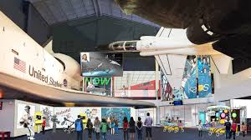
Orbiting Opportunity: A Community Development
Journey Through the Kansas Cosmosphere

Date & Time: 6/17/2026 , 1:00 P.M.
(Depart Wichita @ 12:00 P.M- Return @4:30 P.M.)
Duration: 2.5 hours
Capacity: 50 Participants
Price: $ $40.00

Discover how a world‑class aerospace museum in the heart of rural Kansas fuels community identity, regional economic vitality, and long‑term development. This mobile workshop takes participants to the Kansas Cosmosphere in Hutchinson, a globally recognized STEM and space‑science attraction that draws visitors, educators, and industry partners from across the country. The workshop highlights how rural communities leverage unique cultural institutions to strengthen workforce pipelines, attract tourism dollars, support local businesses, and cultivate community pride.

Important Notes:
- Space is limited to 50 attendees – register early!

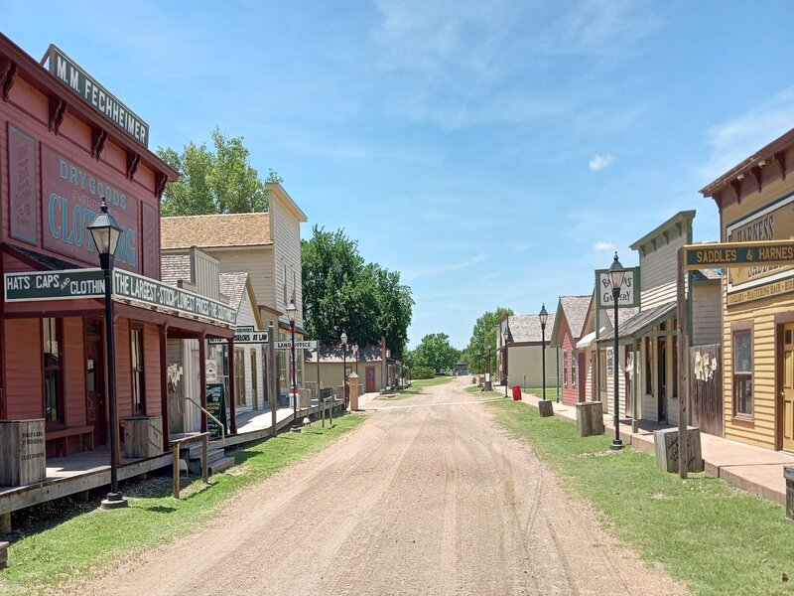
Building Community from History: Chisholm Trail and Delano, where the West was Wild!

Date & Time: 6/17/2026, 12:30 P.M.
Duration: 3 Hours
Capacity: 50
Price: $28.00

Participants will see how Wichita has built on its Old West/Chisholm Trail history for community development. Those on this tour can experience the historic Delano district along the Chisholm Trail, observe the community development near the Kansas River, and experience Old West history at the Old Cowtown Museum. Participants will take a quick walk from the Drury Hotel along Douglas Avenue across the Kansas River bridge and enter the infamous Delano District, a Chisholm Trail destination. A longhorn sculpture and historic marker will greet participants before they reach the beautiful Clock Tower. Stops along the tour will include:

- Delano District- Delano was where the aircraft industry began in Wichita – a city now known as the Air Capitol. Other features to be highlighted include the streetscape in Delano, unique shops, and the Chisholm Trail Parkway. A bus ride will take participants by a 100-year-old mulberry tree which was a historic marker for the Chisholm Trail. From there bus riders would be shown the new baseball stadium, the Keeper of the Plains statue, the Mid-America All Indian Center, Wichita Art Museum and Exploration Place on the way to Old Cowtown Museum for a guided tour.
- Old Cowtown Museum - Old Cowtown Museum is one of the oldest open-air history museums in the central United States, with 54 historic and re-created buildings situated on 23 acres of land off the original Chisholm Trail. Visitors can walk the 1870s-era streets, visit the Texas longhorns, see the pioneer farm, view the new Billy the Kid monument, enjoy a cold sarsaparilla, and more.

Important Notes:
- Space is limited to 56 attendees – register early!

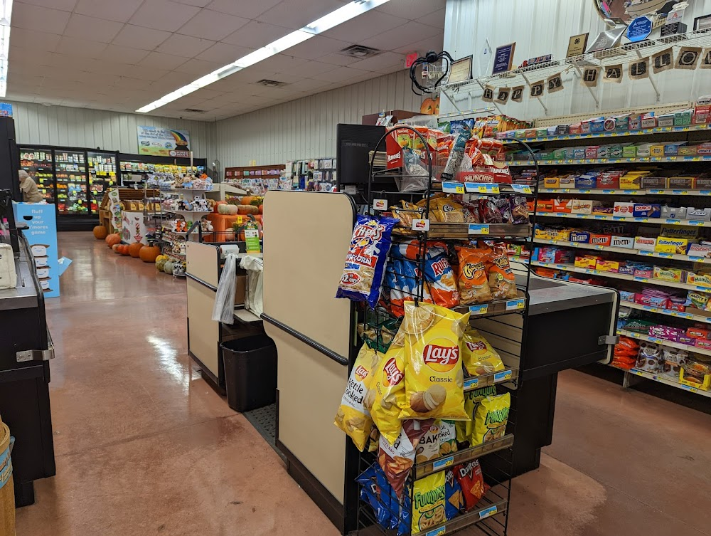
Blueprints for Rural Grocery Success Tour: Sumner County Grocery & Food Access

Date & Time: 6/17/2026, 12:30 P.M.
Duration: 4 hours
Capacity: 50
Price: $38.00

Visit two rural grocery stores located south of Wichita. We will visit Hired Man's Grocery in Conway Springs, and Ellis Island Farm in Belle Plaine. Hired Man's Grocery was built from the ground-up in 2007 and opened in 2008 by lifetime Conway Springs residents. Ellis Island Farms was established in response to the community losing their long-time grocery store. Michelle Ellis responded by beginning to carry groceries within her boutique, the community has responded and Michelle continues to meet her communities needs and working with local farmers to sell produce. A team member from K-State's Extension's Rural Grocery Initiative will also be on the tour and will be able to share resources regarding how we provide technical assistance to rural grocers across the United States.

Important Notes:
- Space is limited to 30 attendees – register early!
- A snack will be provided at each stop for a taste of Kansas!

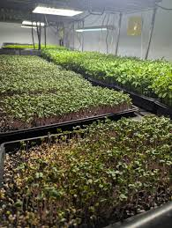

From Farm to Plate- KanGrow Hydro Farms and Odd Fellows Hall

Date & Time: 6/17/2026, 12:30 P.M.
Duration: 4 Hours
Capacity: 30
Price: $40.00

Get a behind the scenes tour of Kan Grow Hydro Farm, farmer and chef Jimmy Vo will give you a tour of his operation. His farm focuses on regenerative agriculture and also supports agricultural education through the Growing Growers program. Then Jimmy will join us to tour Odd Fellow Hall. This event space is in the historic Delano District and has undergone a full renovation. Jimmy is one of the chefs often catering and hosting events in the space. You will enjoy learning from Jimmy as he truly takes Farm to Plate!

Important Notes:
- Space is limited to 30 attendees – register early!
- There will be a walk around the farm so appropriate attire is recommended.

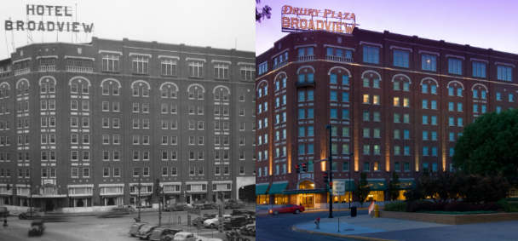
Community Development in
the Heart of Wichita

Date & Time: 6/17/2026, 1:00 P.M.
Duration: 2.5 hours
Capacity: 25
Price: $0.00

See many historical items of interest as well as recent economic development projects which make Douglas Avenue a gathering place in Wichita. Like many downtowns, Douglas Avenue declined as the suburbs developed. See and hear how intentional placemaking efforts have revitalized downtown Wichita and made Douglas Avenue “the place to be” once again.

- Stories and stops include:
- 1958 Dockum Drug Store: The role of the 1958 Dockum Drug Store in ending segregation at Rexall Drug Stores
- Old Mill Tasty Shop – Sit for a spell at the oldest fountain in Wichita, founded in 1932 during the depression. Participants will be treated with a soda from the fountain.
- Kansas Health Foundation/Kansas Leadership Center: Hear why one of the largest foundations in Kansas chooses to partner with K-State Extension.
- Placemaking efforts: Gallery Alley, an interactive arts and culture spot with small businesses along the alley. Naftsger Park, a community gathering spot for live events of all kinds.
- Following the last stop, Participants can walk back to the hotel or visit with new friends at the Dockum Speakeasy in the Ambassador Hotel over an adult beverage of their choice.

Important Notes:
- Space is limited to 25 attendees – register early!
- This is a 1.4 mile walking tour on flat terrain- please dress and plan accordingly.

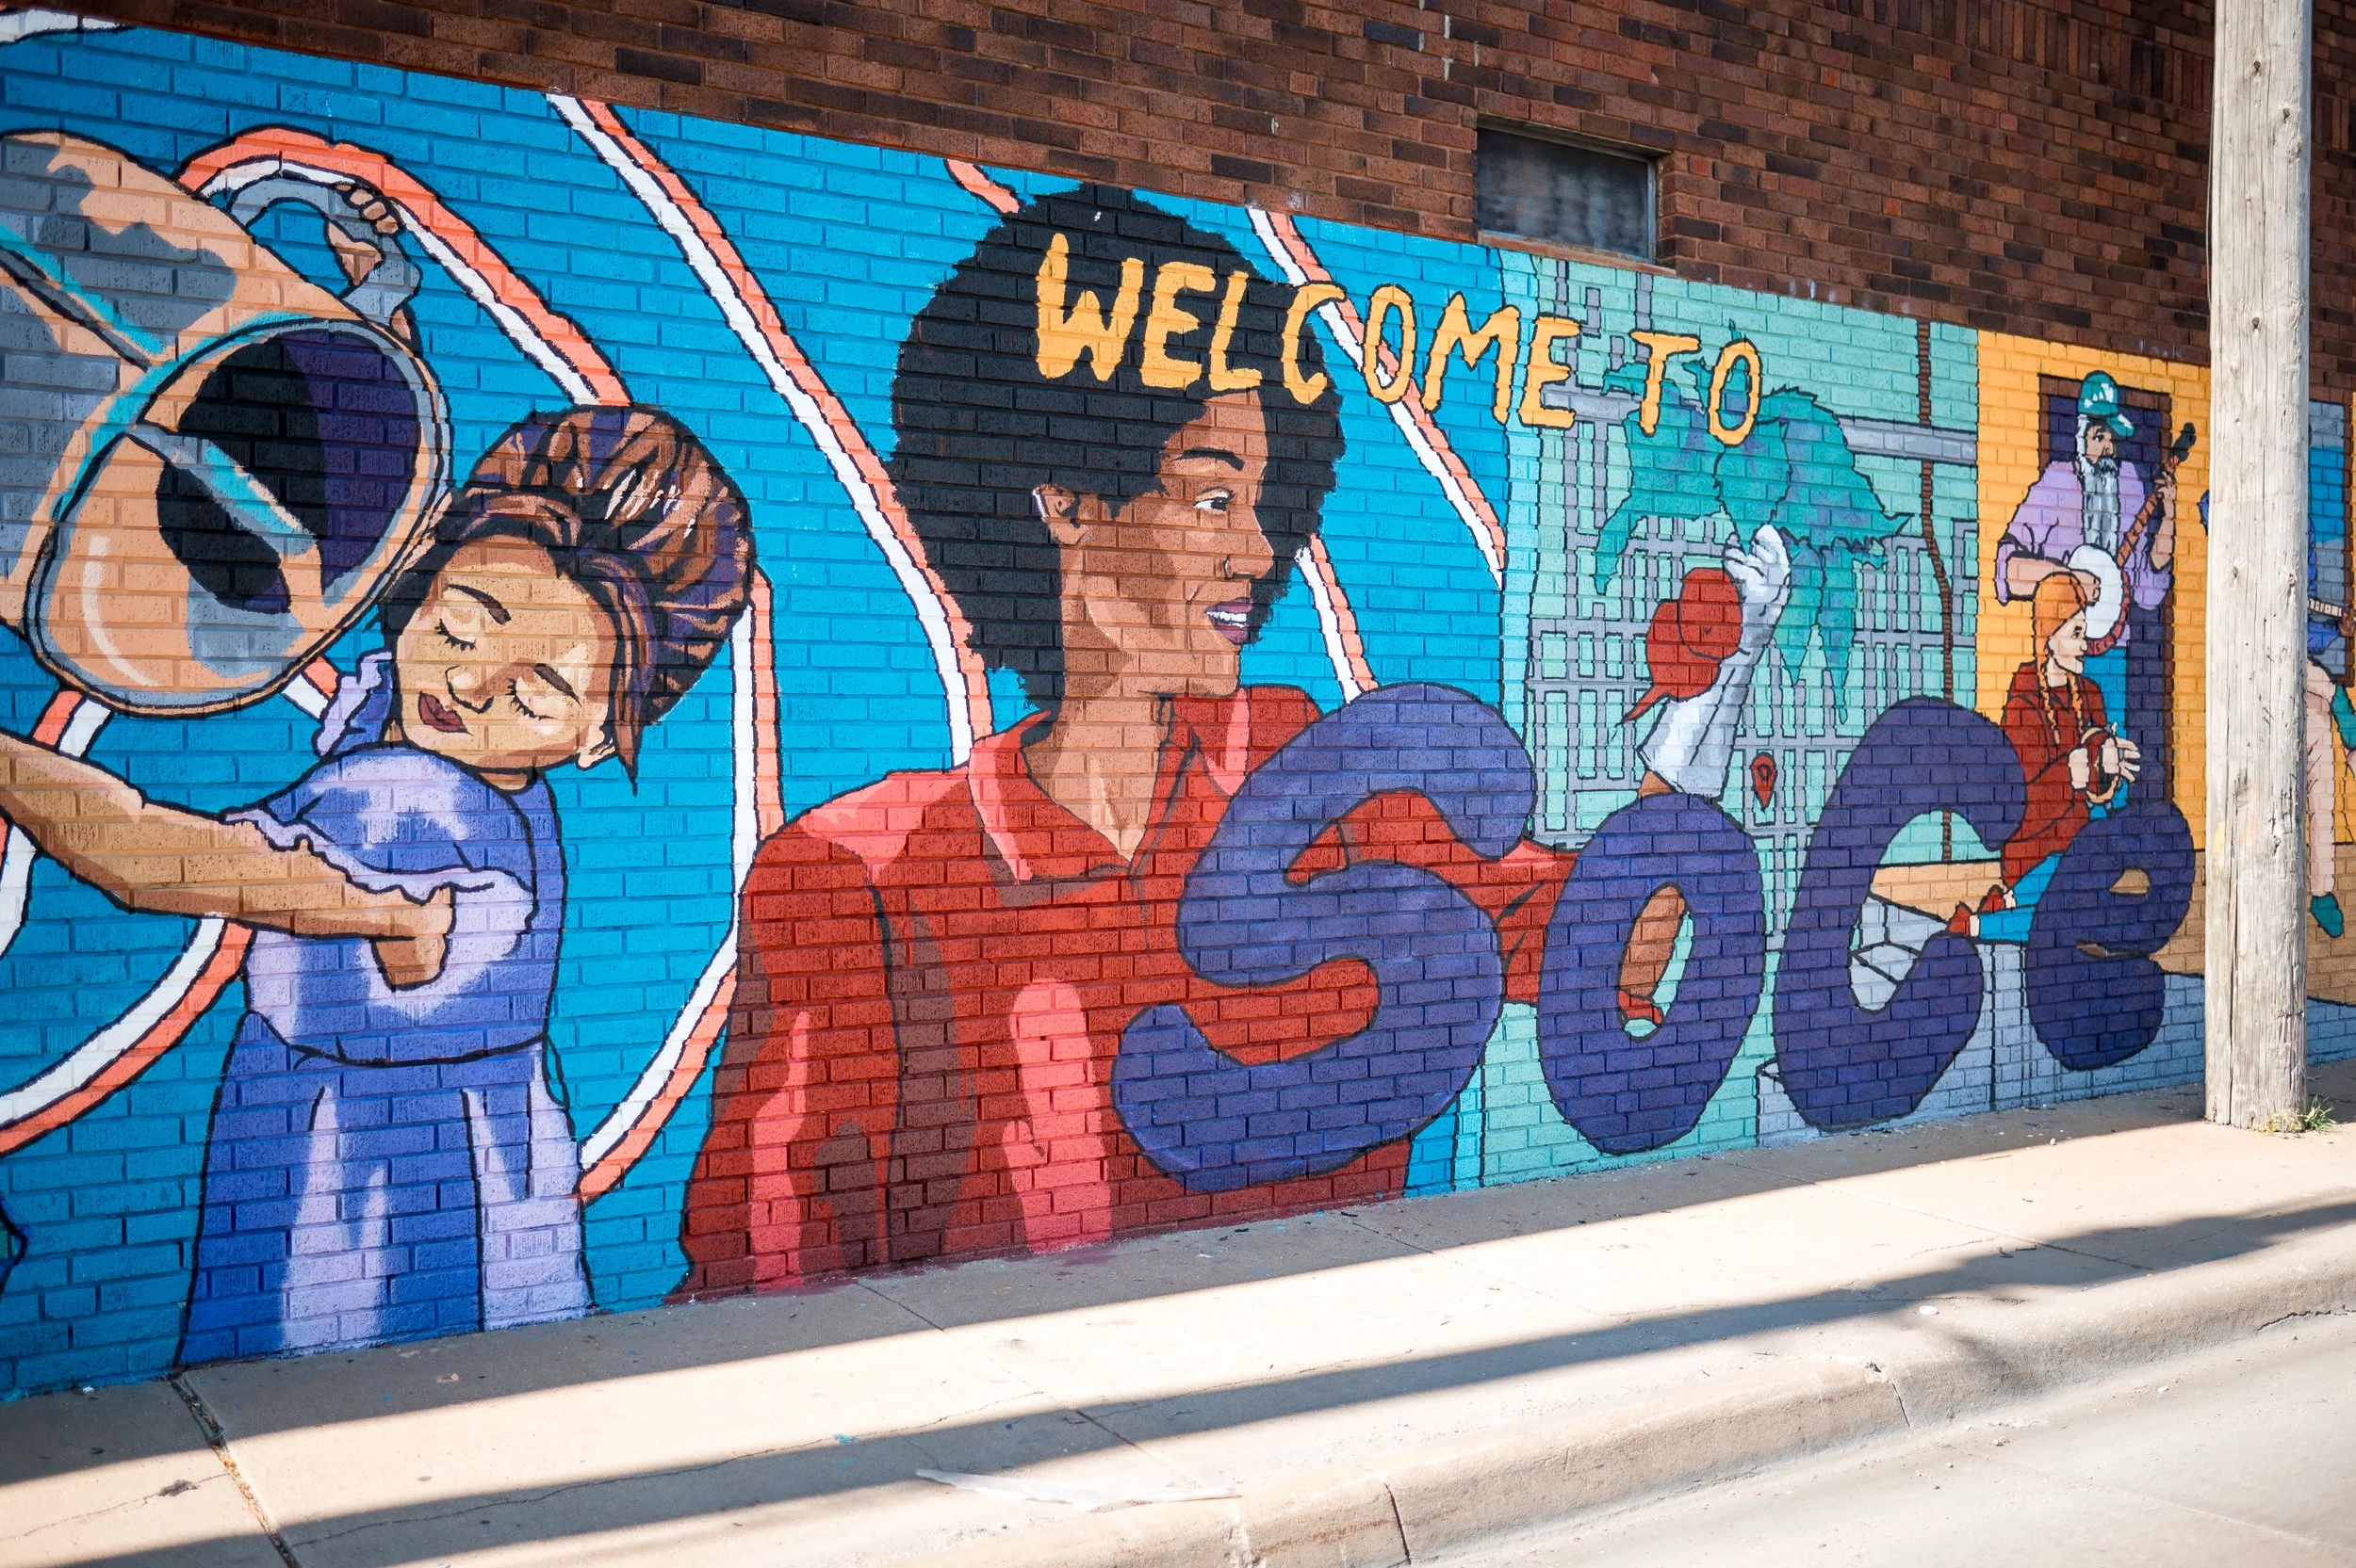
Where Change Takes Root:
A Tour of Neighborhood Innovation with
The Neighboring Movement

Date & Time: 6/17/2026, 12:30 P.M.
Duration: 4 hours
Capacity: 56 Attendees
Price: $50.00

Join us to discover how The Neighboring Movement transforms communities through asset-based community and economic development and strategic partnerships. This interactive tour will take you through real-world examples of our economic development work in the South Central neighborhood—from an urban corner revitalization project to innovative nonprofit spaces such as Legacy Works ICT and Harvester Arts. You'll learn how we mobilize neighbor gifts and resources to create sustainable change, exploring everything from our nonprofit-to-impact fund structure to the power of community investment. Come see firsthand how abundance thinking and relationship-building spark lasting transformation right where people live.

Important Notes:
- Space is limited to 56 attendees – register early!
- There are plans to taste some of the best tacos in Wichita on this tour too!

